

Centamin plc LSE:CEY
FQ1 2016 Earnings Call Transcripts
Tuesday, May 03, 2016 8:00 AM GMT
S&P Global Market Intelligence Estimates
 | -FQ1 2016- |  |  | -FQ2 2016- | -FY 2016- | -FY 2017-
 | CONSENSUS | ACTUAL | SURPRISE | CONSENSUS | CONSENSUS | CONSENSUS
EPS Normalized | 0.03 | 0.04 | 33.33 | - | 0.10 | 0.09
Revenue (mm) | 147.54 | 148.11 | 0.39 | 145.69 | 576.40 | 607.84
Currency: USD
Consensus as of Apr-28-2016 6:07 AM GMT

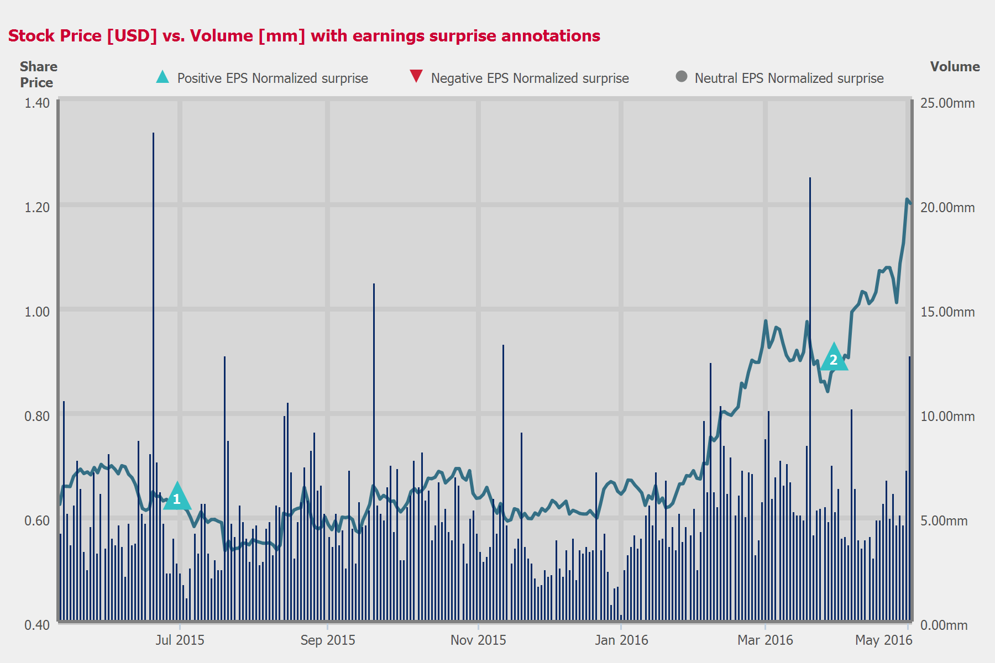
 |  |  |  | - EPS NORMALIZED -
 | CONSENSUS |  | ACTUAL |  | SURPRISE
FQ2 2015 | 0.02 |  | 0.03 |  | 50.00 %
FQ3 2015 | - |  | - |  | -
FQ4 2015 | 0.02 |  | - |  | -
FQ1 2016 | 0.03 |  | 0.04 |  | 33.33 %

Table of Contents

Call Participants | ........................................................................................................................................................ | 3
Presentation | ........................................................................................................................................................ | 4
Question and Answer | ........................................................................................................................................................ | 6

Call Participants
EXECUTIVES
Andrew Davidson
Former Head of Investor Relations
ANALYSTS
James Andrew Keith Bell
BofA Merrill Lynch, Research Division
Nick Hatch
Canaccord Genuity Corp., Research Division
Richard James Hatch
RBC Capital Markets, Research Division

Presentation
Operator
Ladies and gentlemen, thank you for standing by. Hello, and welcome to the Centamin Q1 results conference call. [Operator Instructions] Just a reminder, this conference call is being recorded.
Today, I'm pleased to present Andy Davidson, Head of Investor Relations. Please begin your meeting, sir.
Andrew Davidson
Former Head of Investor Relations
Thank you very much, and thanks, everyone, for joining me on the call. Firstly, apologies from Andrew Pardey, who is traveling at the moment and has been unable to dial-in. He may be able to join us probably through the call, but I'll press ahead anyway.
So just in summary, we delivered a strong start to the year. First quarter production is at the top end of our 450,000 to 500,000 ounces per annum range and a continued downward trend in costs. The higher production and lower costs have given a further boost from the rising gold price. EBITDA rising by 42% in the fourth quarter to $675 million. Strong free cash flow generation so our cash and liquid assets balance increased by $45 million to $276 million. And of course, we remain debt and hedge free as per our long-standing policy.
The $603 per ounce cash operating cost was a material reduction on the previous quarter and below our full year guidance of $680 an ounce. It's partly due to the lower fuel cost, but we're also starting to see productivity improvements and this year's big drive for cost efficiency is reflected in these financial results or starting to be.
All-in sustaining costs of $758 per ounce was also down on the fourth quarter and also down on full year guidance of $900 per ounce. Sustaining CapEx was lower in the first quarter than we expect for the remaining quarters as the scheduled higher maintenance spend comes through in the remainder of the year.
Operationally, at Sukari, the processing function was a highlight and a key driver of the increasing gold output, with plant throughput rising above our base forecast of 11 million tonnes per annum as the optimization program continued.
The mining operations also performed well. The open pit delivered a 10% increase to material movement and hit our 66 million tonne per annum target rate in March. Productivity from the underground exceeded our base case target of 1 million tonne per annum at 6 grams a tonne on both tonnes and grade. Particularly pleasing, in light of all that good operational performance is at the same time we met our safety target of 0 lost time injuries, and that's again a testament to the strong culture of safety and professionalism amongst our workforce. So it's a very key highlight for us.
Our exploration in Burkina Faso continues to build evidence as a number of potentially economic high-grade mineralized structures. So we continue to update the market over the coming quarters on progress towards our ultimate aim there of establishing a low-cost and a high-return project.
So solid start to the year in all, increasing production, reducing costs, delivering cash flow and progress towards our long-term growth targets.
Our full year guidance remains unchanged at 470,000 ounces at $680 an ounce cash operating cost and $900 an ounce all-in sustaining costs. The key focus for the operation is on sustaining and improving upon these levels of productivity and on continuing to drive costs lower. Ultimately, this offers a potential to deliver higher production and lower costs in our base case forecast, which is in our presentation and which we've talked about for some time now.
And with that, I'd like to hand back over to the operator for any questions, please. Thank you.

Question and Answer
Operator
[Operator Instructions] The first question comes from Richard Hatch from RBC.
Richard James Hatch
RBC Capital Markets, Research Division
Andy, just on the underground, I know the grade was very robust at 7.77 grams. And can you talk a little bit about how you expect the grade to evolve over the coming quarters, and what your expectations are for the underground for the full year? I mean, basically do you see this grade continuing, or do you see it drifting off a little bit in line with the mine plan?
Andrew Davidson
Former Head of Investor Relations
Yes, sure. Yes, I mean, we're going to get some variability over shorter-term horizons as to be expected as you all know, particularly in the higher-grade underground mining operations. So we've at the same time given the 6 grams a tonne forecast as a base case. We've said that we can do better than that, and we have done better than that in the past. Having said that, we've mined some higher grade stopes in the fourth quarter last year and into this first quarter just gone. And also in those periods we had less of a contribution than we did through a couple of quarters last year from lower grade development or in the -- which essentially meant that we mine more tonnes and that diluted grade slightly as we went through some areas that were forecast to be waste, but were essentially -- turned out to be low grade ore that, obviously, we put into the mill. So we had less of an effect from that in the first quarter and also in the fourth quarter last year. So I mean, the objective here really is to -- remains really to mine at least 1 million tonnes of ore, at least 6 grams a tonne, and then work from there. So yes, we probably could do -- we will aim to do better than that, but the forecast for the time being remains 6 grams a tonne.
Operator
The next question comes from Nick Hatch from Canaccord.
Nick Hatch
Canaccord Genuity Corp., Research Division
I'm no relation of Richard's. Just looking at the cost breakdown, you obviously had some big unit savings in the open pit and the processing. And you've alluded to the fact that some of the efficiencies are likely to continue into subsequent quarters. Do you see that mainly on the mining side of things or the processing, or is it pretty much spread across the operation?
Andrew Davidson
Former Head of Investor Relations
Yes, thanks, Nick. It's spread across the operation. I mean, it's a big drive for efficiency for us really across the operation on all fronts. We've had second half 2014 and all through last year, the big focus on productivity getting up to the base case level of production. We obviously always have a big focus on costs, but now the really strong focus is on cost this year. And now we've got our base case level of productivity. And so that's starting, as I said in the intro, to have an impact, and that is across the board. And you're seeing improvements in mining and processing as a result of that, more on the mining side. It's going to obviously be more on the open pit potential for lower costs there. Fuel's a factor as well -- less quarter-on-quarter, I mean, the fuel we paid in the first quarter was $0.42 a liter versus the fourth quarter $0.44, but the average through 2015 was $0.55. So yes, I mean, versus the full year last year we've had a positive impact from continued reduction in fuel prices. Going forward from here, it's about unlocking real operational efficiencies and that's across the board.
Operator
[Operator Instructions] The next question comes from James Bell from Bank of America Merrill Lynch.
James Andrew Keith Bell
BofA Merrill Lynch, Research Division
Just 2 questions. First of all, on phasing of the remainder of the CapEx, obviously, CapEx came in low in Q1. Just wondering how much is looking like it's going to be key to invest in the second half? And secondly, when will you guys look at potentially revising guidance? Obviously, you guys are run rating well ahead, costs are well below. Is that something we're going to potentially see around Q2, once you've got those numbers in the back in terms of production? Or is it something which you'd want to see 3 quarters before you look to revise?
Andrew Davidson
Former Head of Investor Relations
Yes, on just looking on the guidance side, it's results-driven obviously. We had a good start to the year. The first quarter is not -- yes, it's a great start, but it's not sufficient yet to revise guidance. We'll see how we go and certainly hope to be in a position where we keep pushing towards the top end of the 450,000 to 500,000 ounce range, if not better as we've outlined the potential and to the extent that we can do that, then that will bring forward the need to revise guidance. But we'll wait and see how we go in the second quarter for that. On the CapEx, it pretty evenly spreads in here. We had less maintenance charges -- costs in the first quarter. That was a bit of a thing last year as well. We were able to optimize the scheduling of the maintenance of the mobile fleet and defer a lot of those things. Essentially, trucks not showing the hours or not showing the requirement to have the maintenance by pushing longer hours between scheduled maintenance. So it's a good operational improvement. But they are starting to come through now. So we are starting to see an increase in the maintenance costs. So I would expect that to be consistent through Q2, 3, 4 this year, that run-up to meet the full year guidance on costs there.
James Andrew Keith Bell
BofA Merrill Lynch, Research Division
Okay. And then I mean, can you just talk a little bit about underground development, obviously, again with the CapEx spend being low. Is that -- is your sort of underground development running in line with plan, or if you've been spending less in the underground in sort of Q4 and Q1 than you would normally be in terms of run rate?
Andrew Davidson
Former Head of Investor Relations
No, the underground is in line with the spend -- projected spend. We spent $9.2 million on the underground CapEx in the first quarter. I think we've said, yes, it's about -- it's $33 million to $35 million for the year for that portion of sustaining CapEx. So that's -- yes, a shade higher, but nothing significant, that's pretty much in line with the run rate.
Operator
Thank you. There appear to be no further questions. I will turn the conference back to you, sir.
Andrew Davidson
Former Head of Investor Relations
That's great. Okay. Well, thanks, very much. Thanks, everyone, and look forward to catching up with you all again soon. Thanks very much. Cheers.
OperatorThank you. Ladies and gentlemen, this does conclude today's conference call. Thank you very much for attending. You may now disconnect your lines.
Copyright © 2019 by S&P Global Market Intelligence, a division of S&P Global Inc. All rights reserved.
These materials have been prepared solely for information purposes based upon information generally available to the public and from sources believed to be reliable. No content (including index data, ratings, credit-related analyses and data, research, model, software or other application or output therefrom) or any part thereof (Content) may be modified, reverse engineered, reproduced or distributed in any form by any means, or stored in a database or retrieval system, without the prior written permission of S&P Global Market Intelligence or its affiliates (collectively, S&P Global). The Content shall not be used for any unlawful or unauthorized purposes. S&P Global and any third-party providers, (collectively S&P Global Parties) do not guarantee the accuracy, completeness, timeliness or availability of the Content. S&P Global Parties are not responsible for any errors or omissions, regardless of the cause, for the results obtained from the use of the Content. THE CONTENT IS PROVIDED ON "AS IS" BASIS. S&P GLOBAL PARTIES DISCLAIM ANY AND ALL EXPRESS OR IMPLIED WARRANTIES, INCLUDING, BUT NOT LIMITED TO, ANY WARRANTIES OF MERCHANTABILITY OR FITNESS FOR A PARTICULAR PURPOSE OR USE, FREEDOM FROM BUGS, SOFTWARE ERRORS OR DEFECTS, THAT THE CONTENT'S FUNCTIONING WILL BE UNINTERRUPTED OR THAT THE CONTENT WILL OPERATE WITH ANY SOFTWARE OR HARDWARE CONFIGURATION. In no event shall S&P Global Parties be liable to any party for any direct, indirect, incidental, exemplary, compensatory, punitive, special or consequential damages, costs, expenses, legal fees, or losses (including, without limitation, lost income or lost profits and opportunity costs or losses caused by negligence) in connection with any use of the Content even if advised of the possibility of such damages. S&P Global Market Intelligence's opinions, quotes and credit-related and other analyses are statements of opinion as of the date they are expressed and not statements of fact or recommendations to purchase, hold, or sell any securities or to make any investment decisions, and do not address the suitability of any security. S&P Global Market Intelligence may provide index data. Direct investment in an index is not possible. Exposure to an asset class represented by an index is available through investable instruments based on that index. S&P Global Market Intelligence assumes no obligation to update the Content following publication in any form or format. The Content should not be relied on and is not a substitute for the skill, judgment and experience of the user, its management, employees, advisors and/or clients when making investment and other business decisions. S&P Global Market Intelligence does not act as a fiduciary or an investment advisor except where registered as such. S&P Global keeps certain activities of its divisions separate from each other in order to preserve the independence and objectivity of their respective activities. As a result, certain divisions of S&P Global may have information that is not available to other S&P Global divisions. S&P Global has established policies and procedures to maintain the confidentiality of certain nonpublic information received in connection with each analytical process.
S&P Global may receive compensation for its ratings and certain analyses, normally from issuers or underwriters of securities or from obligors. S&P Global reserves the right to disseminate its opinions and analyses. S&P Global's public ratings and analyses are made available on its Web sites, www.standardandpoors.com (free of charge), and www.ratingsdirect.com and www.globalcreditportal.com (subscription), and may be distributed through other means, including via S&P Global publications and third-party redistributors. Additional information about our ratings fees is available at www.standardandpoors.com/usratingsfees.
© 2019 S&P Global Market Intelligence.

